Image-Similarity Project — Current Approach and Lora Adapters
Purpose: document the current pipeline in your repo (CAD/DXF view cropping → feature extraction → FAISS vectorstore → similarity search) and describe alternative improvement approaches (reranker, LoRA adapters + triplet training, RLHF-style reward models). Include concrete designs, schemas, diagrams, training & deployment steps, CPU-specific guidance for 200k images, and an implementation checklist.

1. Executive summary
You currently run a pipeline that:
- Scans a directory of CAD-rendered images.
- Uses cad_cropper.py to detect, split and crop discrete view panels from CAD/JPG images.
- Runs an image encoder (BEiT in the repo) to compute embeddings for each crop.
- Builds a FAISS flat/Index (persisted to disk) and provides a Flask API that returns nearest neighbors for a query image.
- The number of images we have in the DXF-CAD images is ~96k, so the possible number of crops if considered 10 per DXF-CAD jpg image are equal to ~1M.
Goal: improve retrieval relevance using human feedback (thumbs up/down). Practical, staged options: (A) LoRA adapter fine-tuning of the encoder (higher ceiling; needs GPU for efficient training).

1.1 Current architecture (detailed)
[CAD image folder]
|
v
cad_cropper.py (detect/split/crop views) -> stores crops in /static/cad_crop/
|
v
ImageProcessor (BEiT) -> embeddings.npy + id->path map
|
v
FAISS Index (IndexFlatL2 or IndexHNSWFlat on CPU) -> saved to disk
|
v
Flask app (/search endpoint) -> query emb -> ANN search -> return results (base64 paths + score)
Key files:
- cad_cropper.py:
- Monitors input buckets/folders for new files and coordinates work via a queue to enable horizontal scaling.
- Loads each CAD image, preprocesses (gray, blur, threshold), applies morphology, contour detection and heuristics to isolate orthographic 'views.'
- Applies OCR-based filters to remove text/table-heavy crops and splits multi-view crops where required.
- Writes each crop to object storage (e.g., s3://cad-crops/<shard>/crop_<id>.png) and records metadata (source path, crop id, bounding box, area, ingestion batch id).

- utils/image_processing.py
- The worker pool consumes crop_ready tasks and computes embeddings using the chosen encoder (BEiT).
- utils/faiss_utils_flat.py
- For 5M vectors, use FAISS flat index to store the embeddings
- Maintain index metadata mapping (index_id -> image_id) and additional metadata for filtering/retrieval
- app.py
- Receives query images, computes query embeddings (inline or via a shared embedding service), issues ANN search queries to the vector DB for top-K candidates, and returns a result.
Persistent artifacts:
- image_paths.npy (N paths or id->path map)
- FAISS index files (index.bin, optionally index_meta.json)

1.2 Design constraints & environment
- Dataset size: ~1000,000 images (crops) → embeddings matrix is large but tractable.
- Current computer: CPU-only machine.
- Latency goal: interactive search (<300-500ms ideally) for users.
- .Memory: depends on vector dimension D (with BEiT D might be 1024 or 1536). Example memory for 1M x 1024 x 4 bytes ≈ 3.9 GB (fits in RAM), but overhead for FAISS + application must be considered.

2. What LoRA does and what changes when applied at 1M scale

2.1 Conceptual effect of LoRA
- LoRA adapters adjust the encoder mapping so embeddings better reflect human-labeled relevance. This reduces semantic retrieval errors and increases hit@K.

2.2 Scale implications (1M)
- Re-embedding cost: re-embedding 1M images is a heavy operation. With GPU workers, re-embedding can be parallelized (e.g., 8 A100 GPUs could process millions of images within hours); on CPU clusters it might take days/weeks. Plan resource allocation accordingly.
- Index rebuild vs incremental update:
  - Full re-embed → full index rebuild: highest quality and simplest. Requires downtime planning or atomic swap strategy.
  - Incremental re-embed → incremental index update: re-embed high-priority shards first (hot items), update indices shard-by-shard, and merge.

2.3 Recommendation for production at 1M
- Use LoRA training on GPUs (single or distributed) and then re-embed incrementally: start with frequently queried items, then background-process remaining shards. Maintain index_vN versions and switch atomically after validation.

3. Detailed LoRA integration design at scale (end-to-end)

3.1 Feedback → training dataset pipeline (industrial)
- Ingest: persist raw feedback in append-only store. Partition by date and user. Rate-limit per-user contributions.
- Clean & dedupe: batch jobs convert raw events into labeled pairs/triplets with noise filtering, user-weighting, and spam detection.
- Hard-negative mining: run FAISS queries daily to extract top-ranked negatives for each query to serve as hard negatives. Maintain a candidate negative pool.
- Dataset sampling: sample balanced batches from positive examples, hard negatives, and random negatives. For large corpora, implement reservoir sampling and priority sampling for new signals.

3.2 LoRA model & hyperparameters (practical)
- Adapter placement: attach to attention projections and/or MLP projections. Start with r=8–16.
- Precision: use mixed precision training (fp16) on GPU for speed and memory efficiency.
- Loss: triplet margin loss or supervised contrastive loss with temperature scheduling. Optionally incorporate ranking losses (e.g., pairwise hinge loss).
- Batching: use large batches when possible; use gradient accumulation to simulate large-batch training.

3.3 Training orchestration
- Use distributed training frameworks (accelerate / PyTorch DDP) for large datasets. For moderate datasets (tens of thousands of triplets), a single GPU with gradient accumulation often suffices.
- Regular checkpointing of LoRA adapters and automatic validation against holdout queries. Store checkpoints in object storage with semantic tags (date, dataset-size, metric scores).

3.4 Validation & rollout
- Validate adapters by re-embedding a validation shard and computing hit@K, NDCG. If metrics improve beyond thresholds, prepare index_vN.
- Canary rollout: expose index_vN to a small percentage of traffic and monitor live metrics (CTR, MRR). If stable/improved, increase rollout.

3.5 Re-embedding strategy at 1M
- Priority re-embed: choose hot items first (top traffic, frequently returned results). Re-embed these in priority and update index shards.
- Parallel re-embed cluster: spawn workers across many GPU nodes or a mix of CPU+GPU. Use batching and checkpointing. Prefer GPUs for speed.
- Index update: if using IVF-PQ/OPQ, you may retrain coarse quantizers on new embeddings; incremental updates must respect index semantics.

4. Vector index maintenance strategy for 1M items

4.1 Index type selection (tradeoffs)
- IVF-PQ (FAISS IndexIVFPQ with OPQ pre-transform): best compromise when memory needs reduction; good for large datasets. Requires training of the coarse quantizer and PQ codebooks.
- HNSW + PQ: excellent recall/latency, but memory overhead for HNSW graphs may be large at 1M (consider memory budget). PQ reduces storage but HNSW meta-structure stays.
- Distributed vector DB (Milvus, Weaviate, Vespa): recommended for 1M+, supports sharding, persistence, replication, hybrid search, and easier ops than raw FAISS.

4.2 Index sharding & federation
- Split corpus into N shards (by hash or date) and build per-shard indexes. For queries, either query all shards in parallel or maintain a routing layer (e.g., metadata-based routing) to reduce fanout.
- Use a federation layer to merge top results from shards and then rerank globally.

4.3 Storage & compression
- Use PQ to compress vectors to small bytecodes (e.g., 8–32 bytes per vector). If D=1024, PQ with 64 subquantizers and 8-bit codes yields compressed sizes that dramatically reduce disk/RAM.
- Consider OPQ for improved quantization.

4.4 Index lifecycle & swapping
- Build index_vN in background. Test on validation shards. Use atomic pointer or service config to switch index references. Retain previous versions for rollback.

5. Operational practices & monitoring (scale-focused)

5.1 Continuous loop
- Feedback ingestion → cleaning → triplet generation → LoRA retraining (periodic) → validation → prioritized re-embed → index rebuild/partial update → canary rollouts → full swap.

5.2 Metrics to track
- Data ingestion: crops/day, embeddings/day
- Index health: index size, memory use, query QPS, average latency, efSearch/nprobe settings
- Model quality: hit@K, Precision@K, NDCG, CTR (live), MRR

6. End-to-end flows

Current Approach:

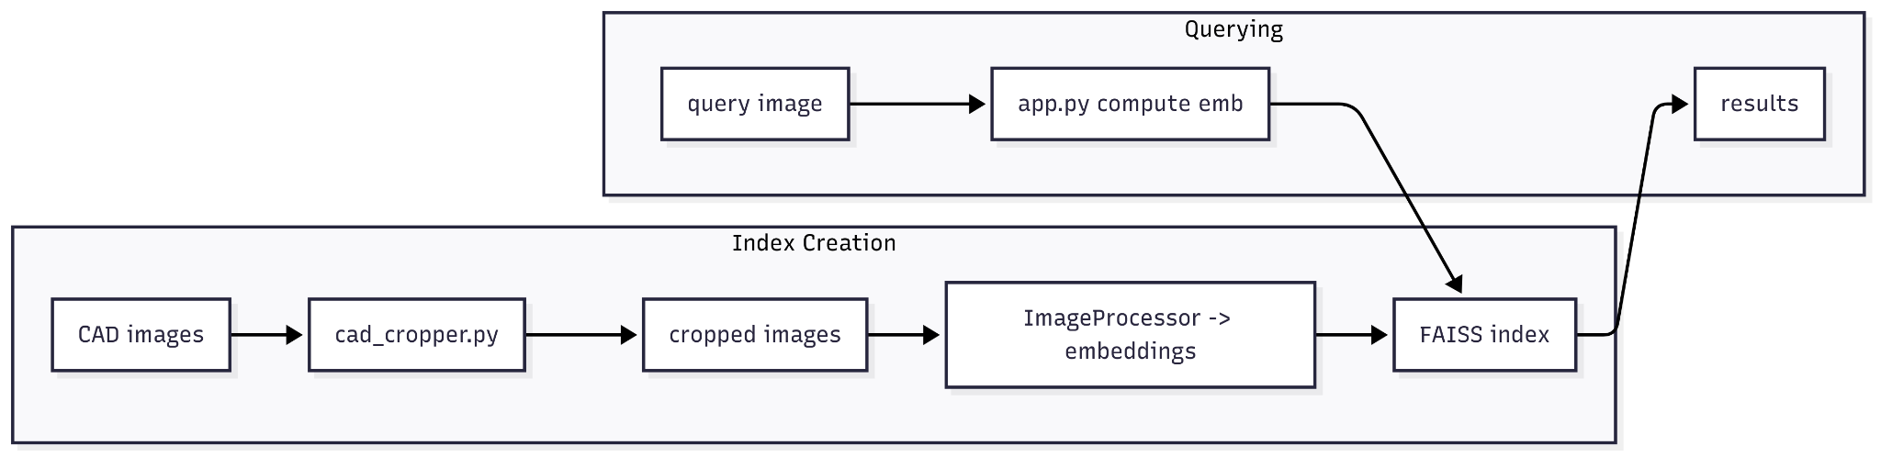

With LoRA fine-tuning
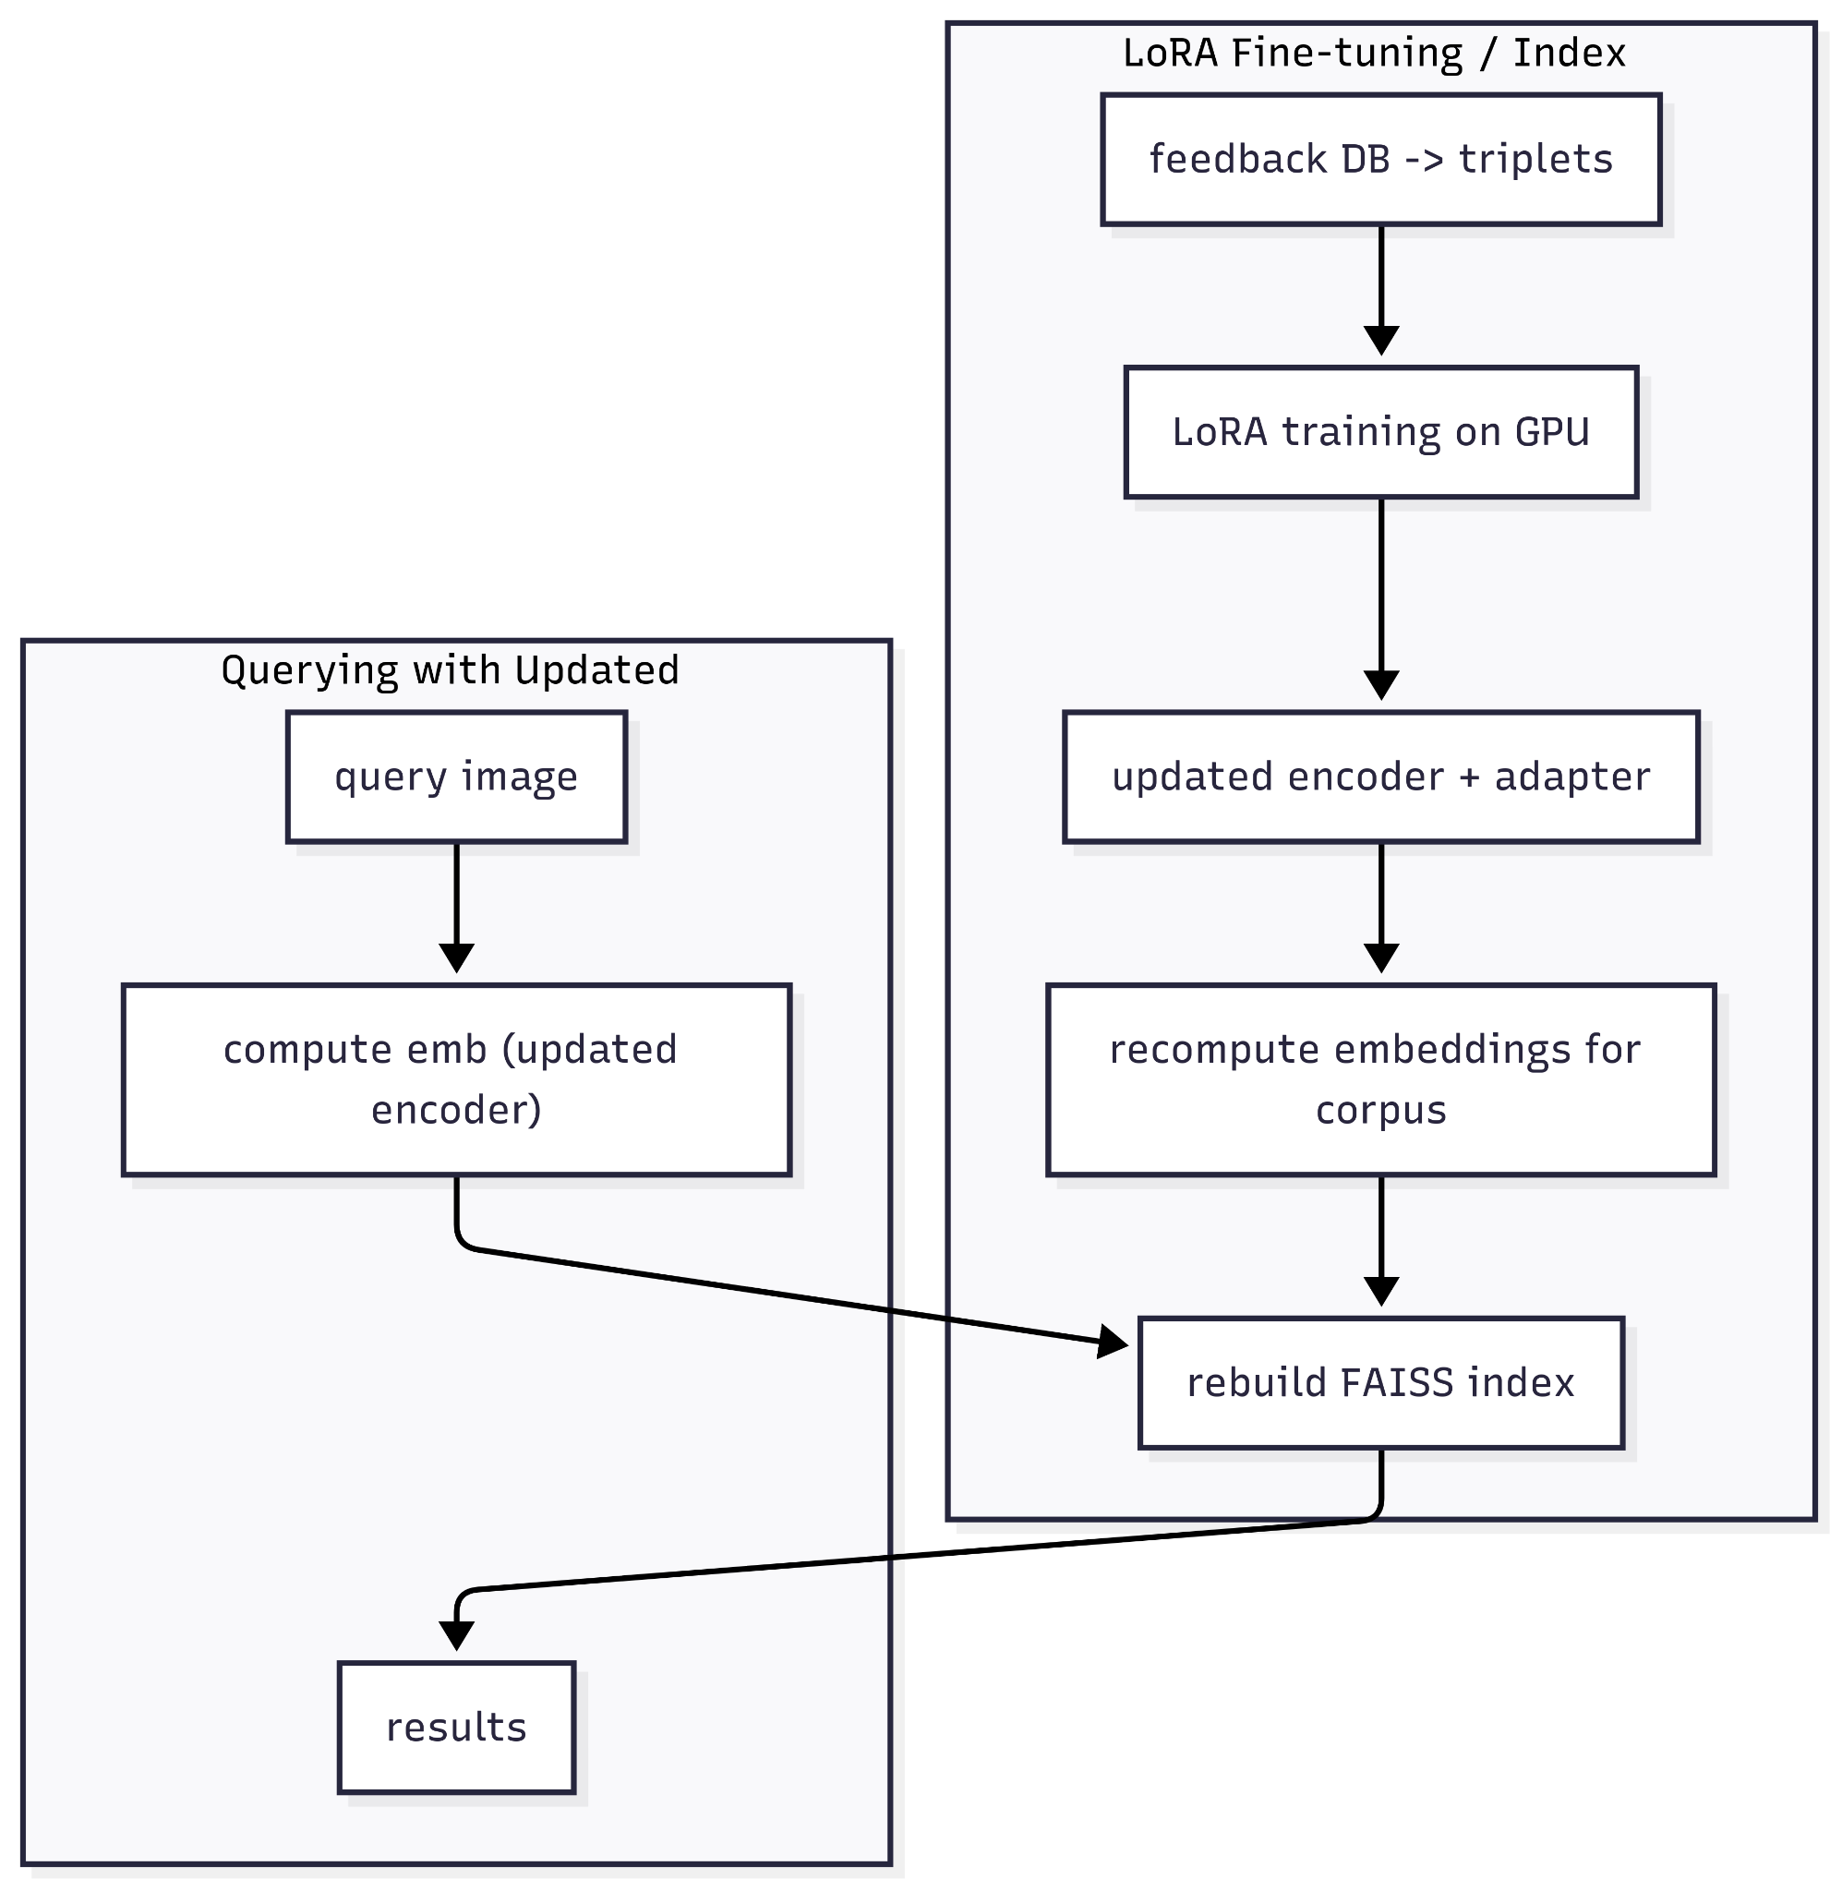

Practical strategies & recommendations (so you minimize recompute cost / time)
- Prefer incremental recompute only for new items (cheap):
  - Recompute embeddings only for the newly added images; leave the old ones intact. This is the most common pattern and gives immediate retrieval improvements for new content.
- Recompute a validation subset of the old DB (e.g., 10k–50k samples) to measure drift:
  - If update degrades overall retrieval metrics, you can roll out a full recompute.
- Use a mapping/regressor to avoid full recompute (fast & cheap approximation):
  - Procedure: after training new LoRA, compute embeddings for a representative sample (e.g., 10k items) under the new model. You now have pairs: (old_embedding, new_embedding) for that sample. Train a small MLP/regressor that maps old_embedding → new_embedding.
  - Apply that learned mapping to all old embeddings (CPU vector transform) to approximate new embeddings without running the full model on 1M images.
  - Cost to compute sample new embeddings: 0.00002 × 10,000 = 0.2 hr → ~$0.10–$0.60. Training a small MLP is cheap (minutes on CPU/GPU). Applying mapping to 1M vectors is fast on the CPU.
  - Tradeoff: this is an approximation; accuracy must be validated. Often works well for small parameter shifts like LoRA updates.
- Run LoRA training in spot/preemptible instances and checkpoint frequently — big $ savings.
- Parallelize recompute across multiple GPUs (if you need wall-clock reduction). Example: 4 GPUs cut wall-clock to ~1/4 while total GPU-hours are the same.

Suggested practical policy (how and when to trigger retrain + recompute)
- Trigger LoRA retrain when either:
  - We accumulate ≥ 10k–50k labeled feedbacks (depends on signal quality), OR
  - Evaluation metrics on holdout drift by > 2–3% (precision@k drop), OR
  - Business threshold (e.g., click-through decreases).
- Recompute embeddings:
  - Always recompute embeddings for the new images immediately after adapter update.
  - Recompute for the whole DB only if validation on sampled old items shows degradation or if adapter change is large.

Minimal commands / pipeline sketch
- Retrain LoRA (resume existing adapters):
python train_lora.py --data new_feedback_dataset.jsonl --epochs 2 --resume_from lora_adapter/

- Recompute embeddings for new images:
python make_embeddings.py --input new_images_list.txt --out s3://.../embeddings/new/

- (Optional) Compute sample paired embeddings to train mapping:
python make_embeddings.py --input sample_old_ids.txt --out local/sample_new.npy --model-with-lora
# train mapping: old_embeds.npy -> sample_new.npy
python train_embedding_mapper.py --old old_sample.npy --new new_sample.npy --save mapper.pt
# apply mapper to all old embeddings:
python apply_mapper.py --mapper mapper.pt --in all_old.npy --out all_old_mapped.npy

Short example summary table (Total combined cost & wall-clock on 1 GPU)
Update size | Epochs | GPU-hours total (train+recompute) | Cost low ($0.5) | Cost med ($1.3) | Cost high ($3.0) | Wall-clock (1 GPU)
10,000 | 2 | 0.6 hr | $0.30 | $0.78 | $1.80 | 36 min
50,000 | 2 | 3.0 hr | $1.50 | $3.90 | $9.00 | 3 hr
100,000 | 3 | 8.0 hr | $4.00 | $10.40 | $24.00 | 8 hr
50k train + full 1M recompute | 2 | 22.0 hr | $11.00 | $28.60 | $66.00 | 22 hr

Data Preprocessing Challnges
- Poor/incorrect crops (partial objects, huge background, empty crops).
- Systematic cropping bias (certain views always cropped worse).
- Image noise / artifacts from scans or conversions.
- Corrupted or missing image files.
- Inconsistent image formats / color channels / resolutions.

Embedding creation challenges
- Poor / noisy crops — partial objects, large background, or blank crops produce bad inputs that poison embeddings.
- Compute & resource limits — getting embedding of large-scale image set (1M images) is slow or infeasible on CPU-only machines.

- CAD-specific representation challenges — fine-grained geometric differences, view/rotation invariances and repetitive patterns make discriminative feature learning hard.

Vector store challenges
Here are the main challenges you’ll hit with a vector store for CAD image search — each with a short explanation.
- Index choice & trade-offs
Picking HNSW vs IVF-PQ vs flat affects latency, memory, update cost and recall — no single best option for all workloads.
- Accuracy vs performance (recall vs latency)
Faster/compact indexes or aggressive quantization reduce memory/latency but usually lower Recall@K.
- Memory footprint & storage
Storing 1M+ high-dim vectors (and possibly metadata) needs lots of RAM or disk space; choices around compression/quantization matter.

